1-Odoo main application

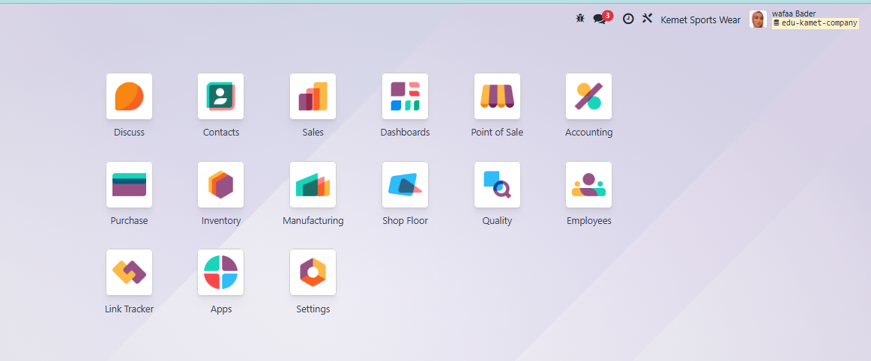

2-Go to sales Module

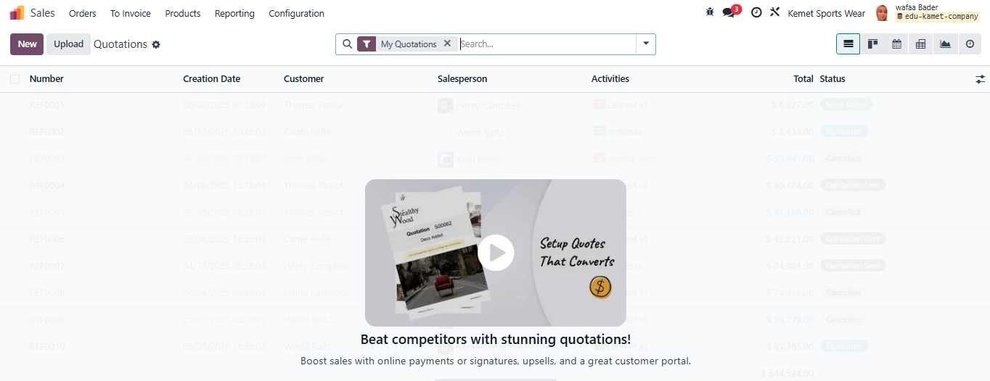

3-Customers under order

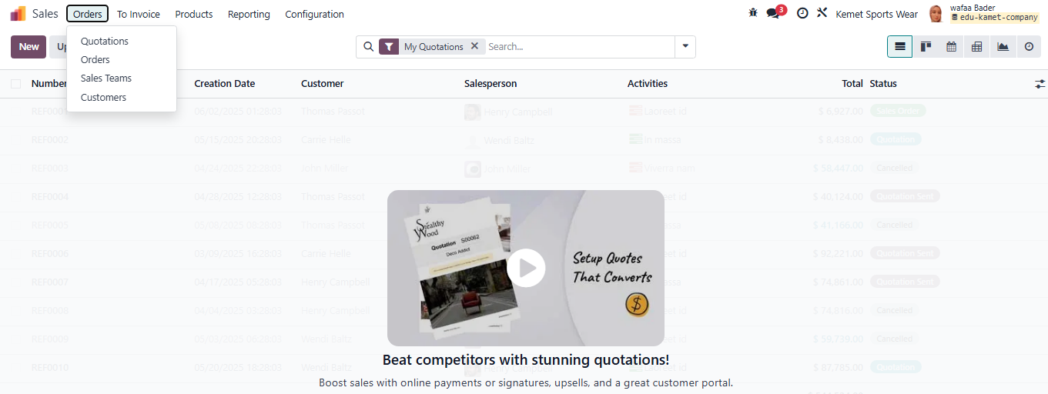

4-Current customers

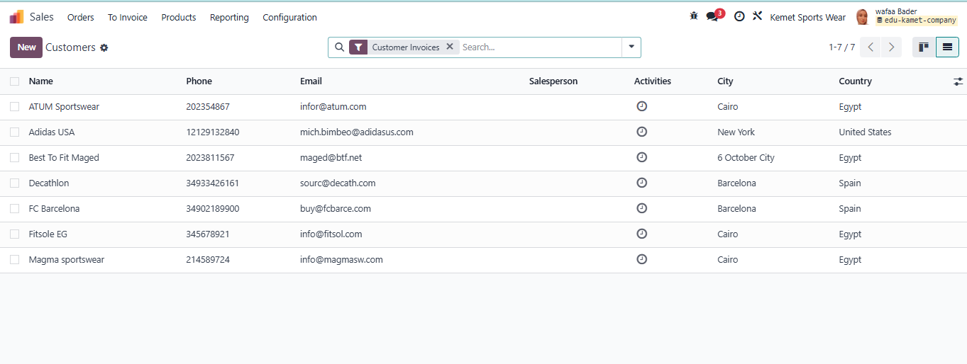

5-Create new customer

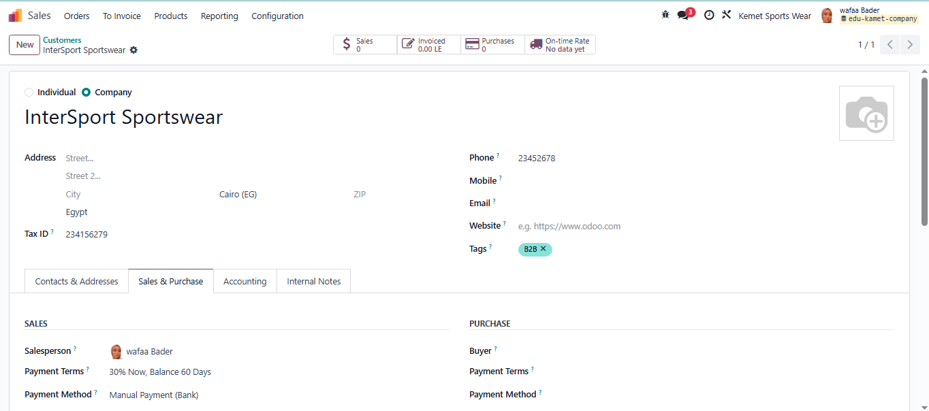

6- Sales setting

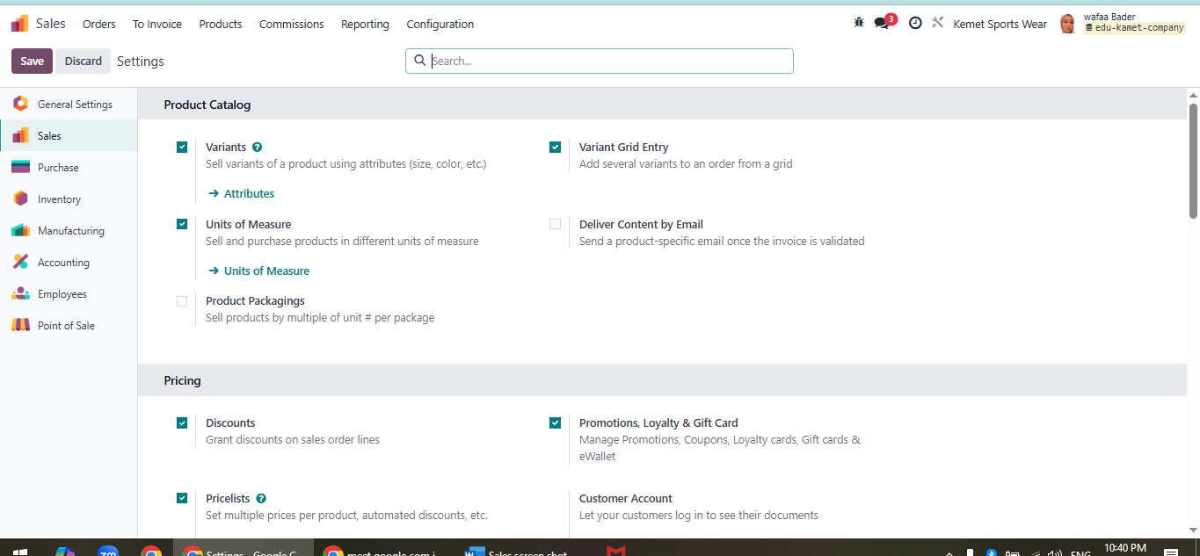

7-Create Sales Quotation

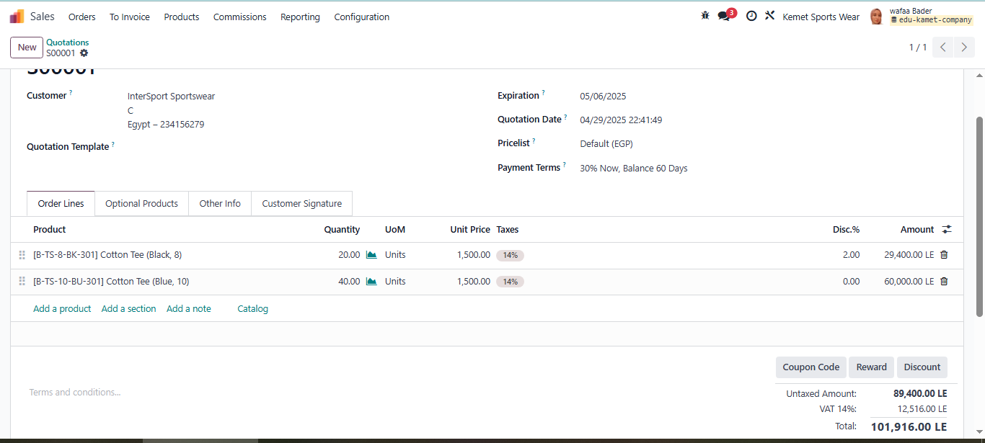

8- Send the sales quotation to customer by Email directly throw Odoo

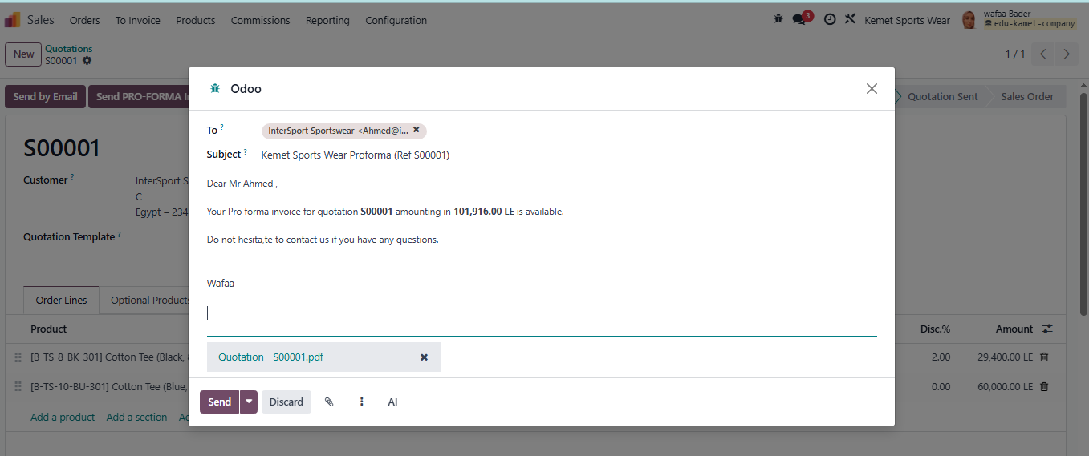

9-Sales team activity indicate that she sent quotation email to the customer

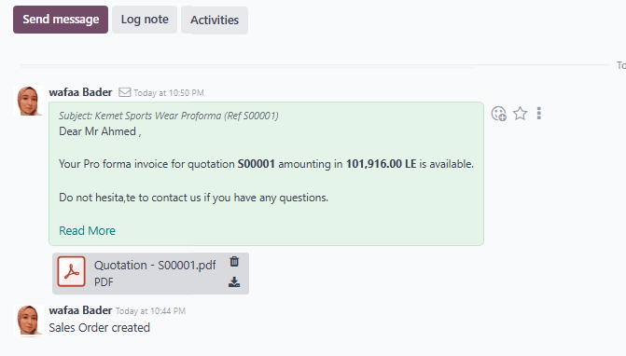

10-Deliver sales order directly from delivery icon to pick out quantity out of warehouse

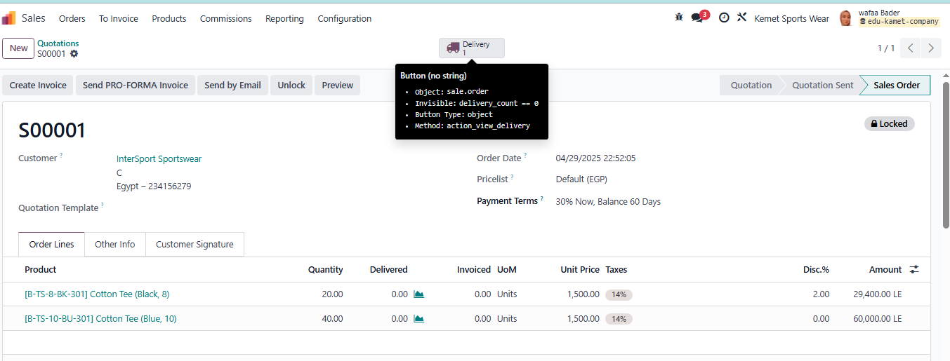

11-Validate stock out of sales order to InterSport customer

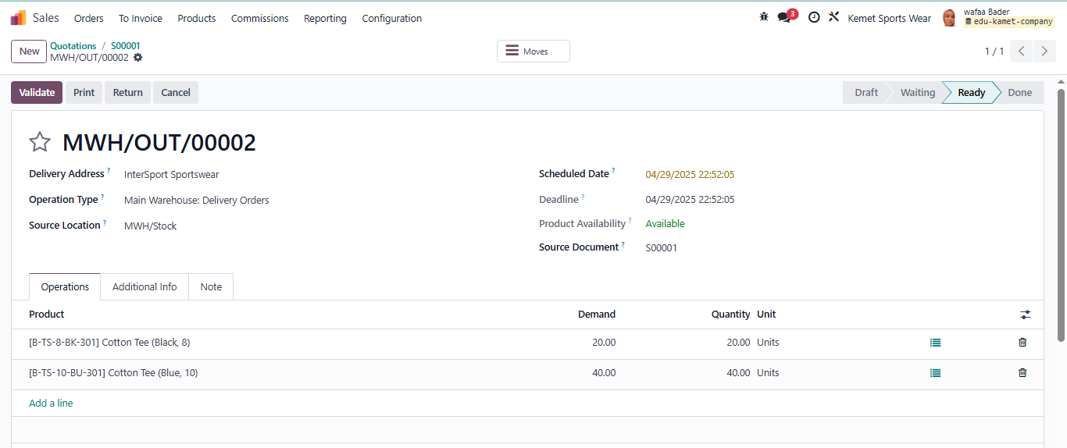

12- SMS sent out of Odoo to the customer that shipment out of warehouse to deliver

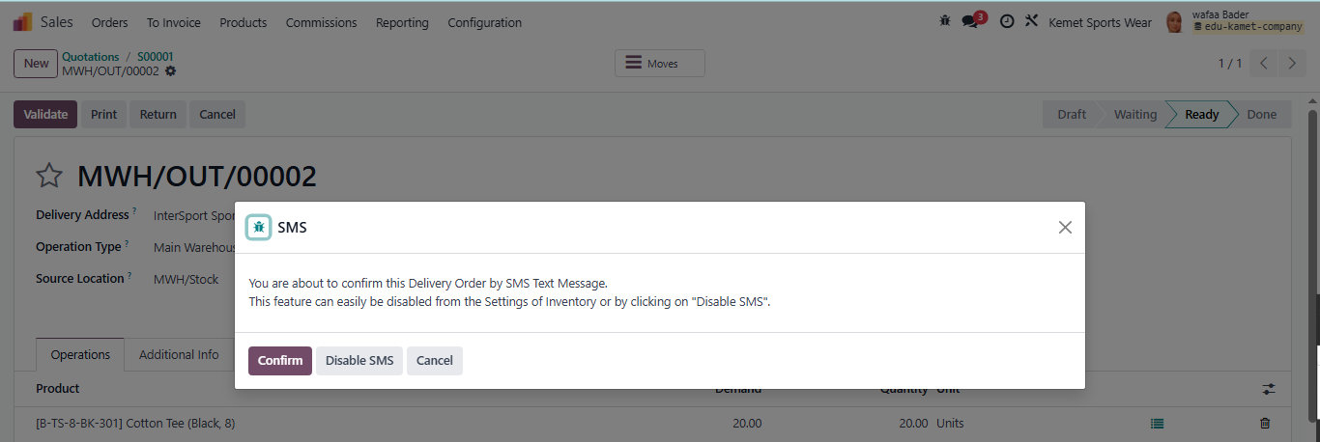

13-Sales order delivered out of our main warehouse to InterSport customer

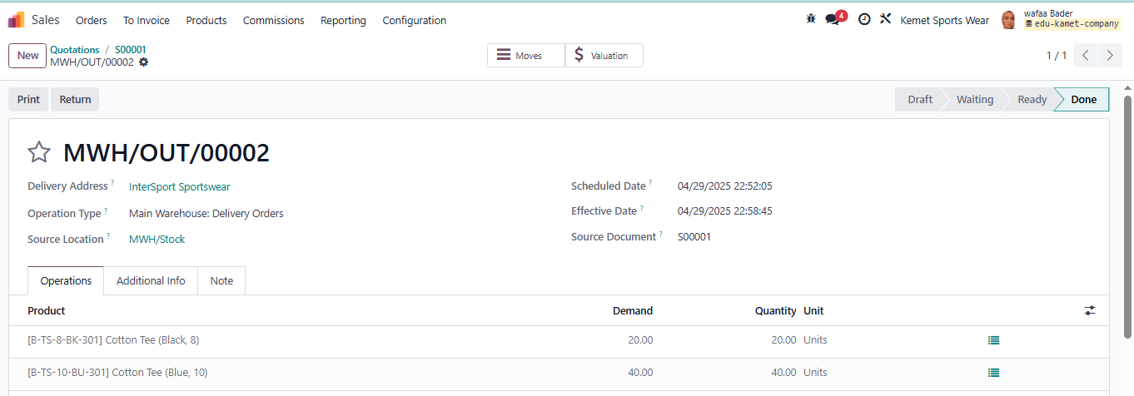

14- Create Customer invoice

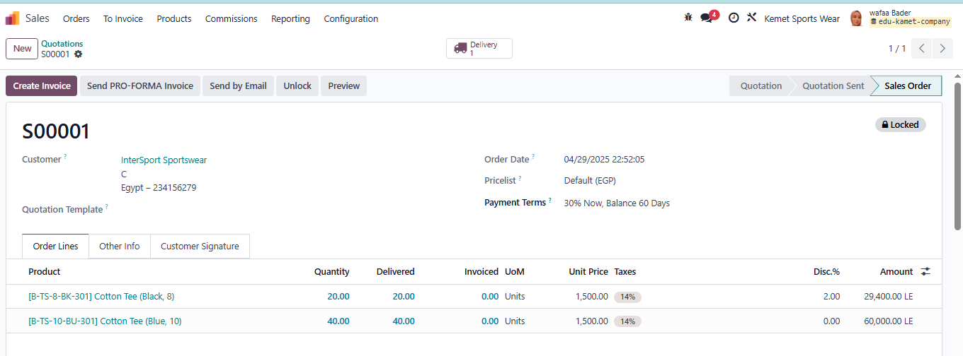

15- Odoo indicates possibility of down payment to collect when issue customer invoice

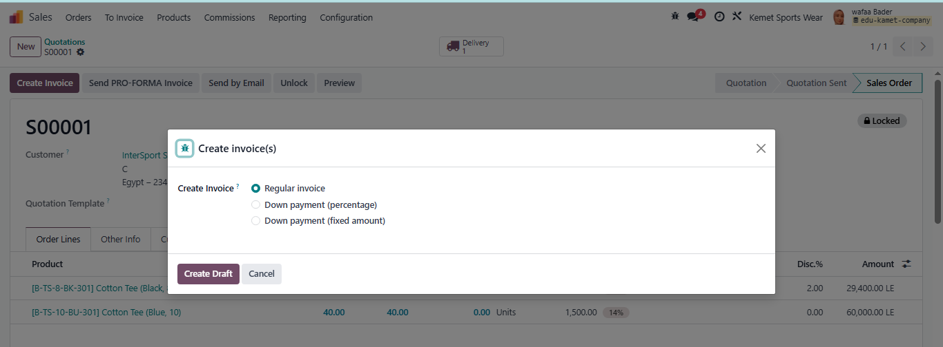

16- Journal Item of sales process

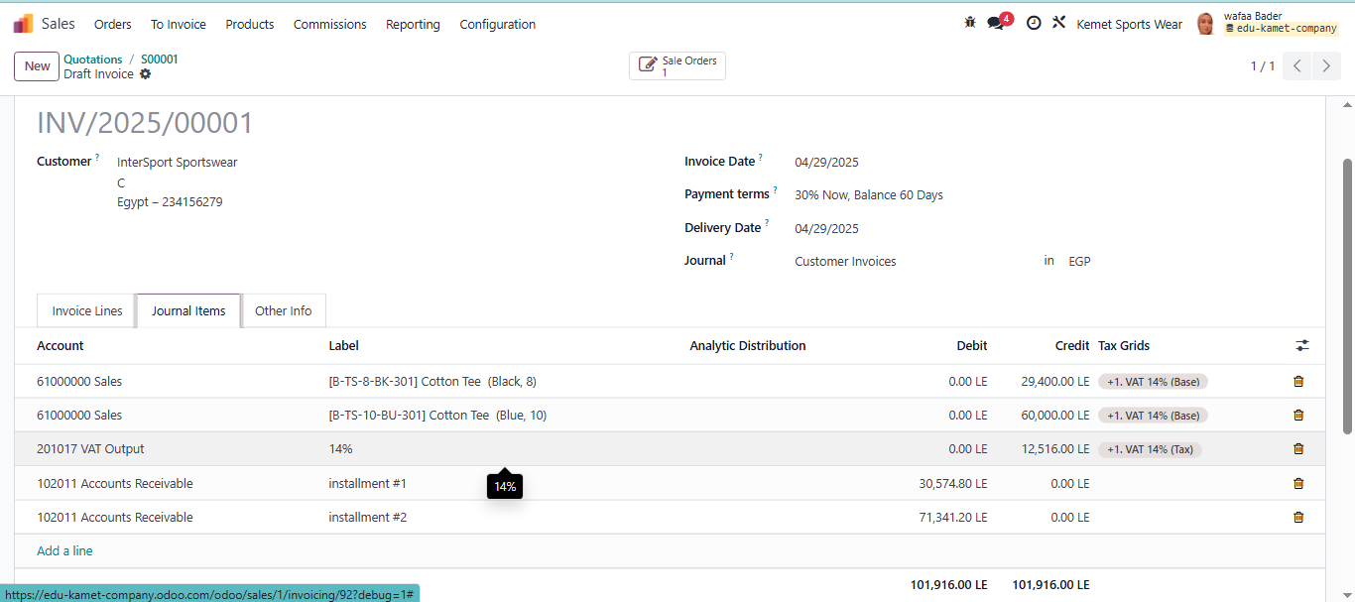

17- Invoice sent by Email to InterSport customer throw Odoo

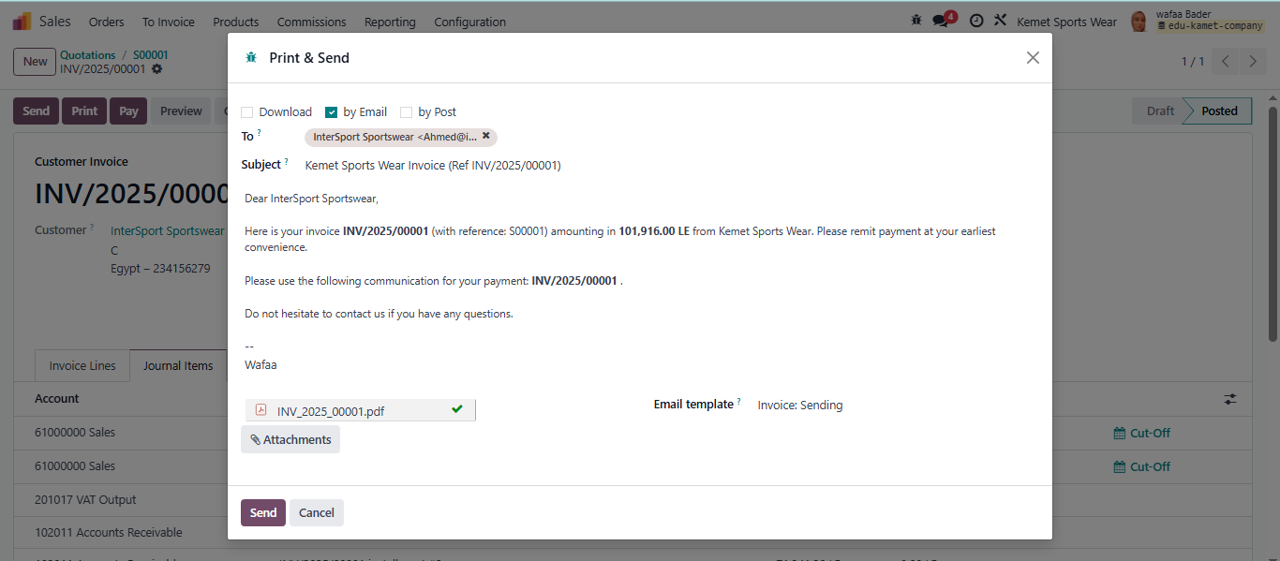

18-collect payment of sales invoice from customer

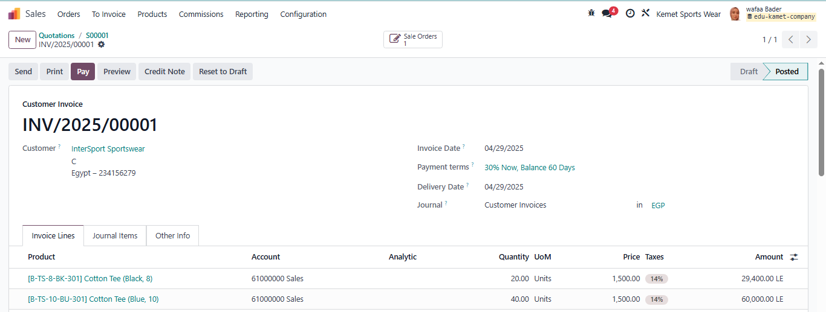

19-collect the payment throw bank as payment term

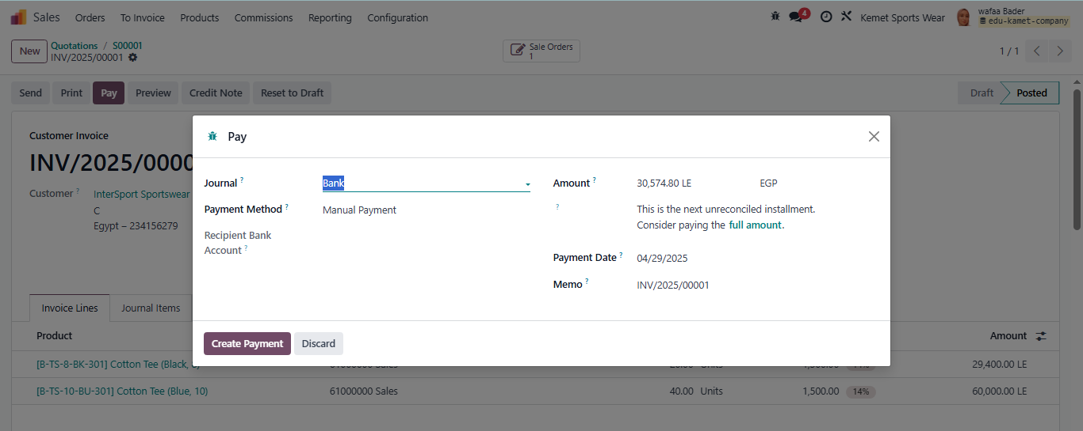

20-the journal items of sales invoice record on the ledger of account receivable and sales revenue

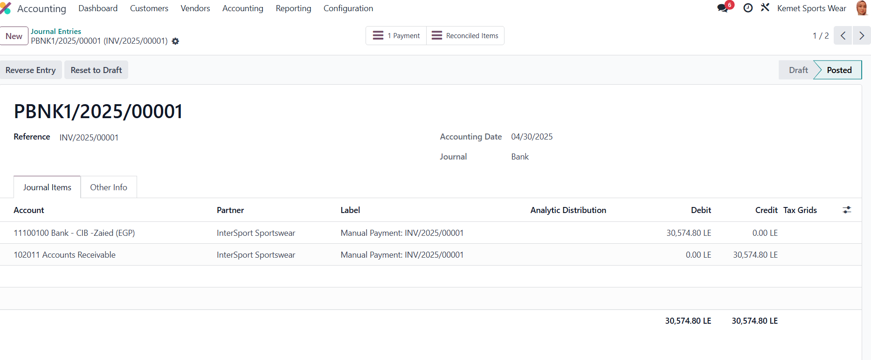

21- create new sales team

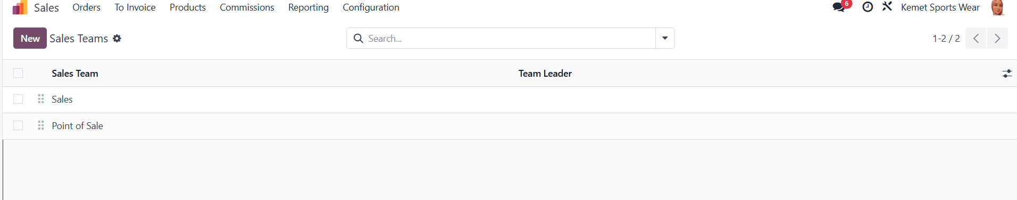

22- create new salesperson 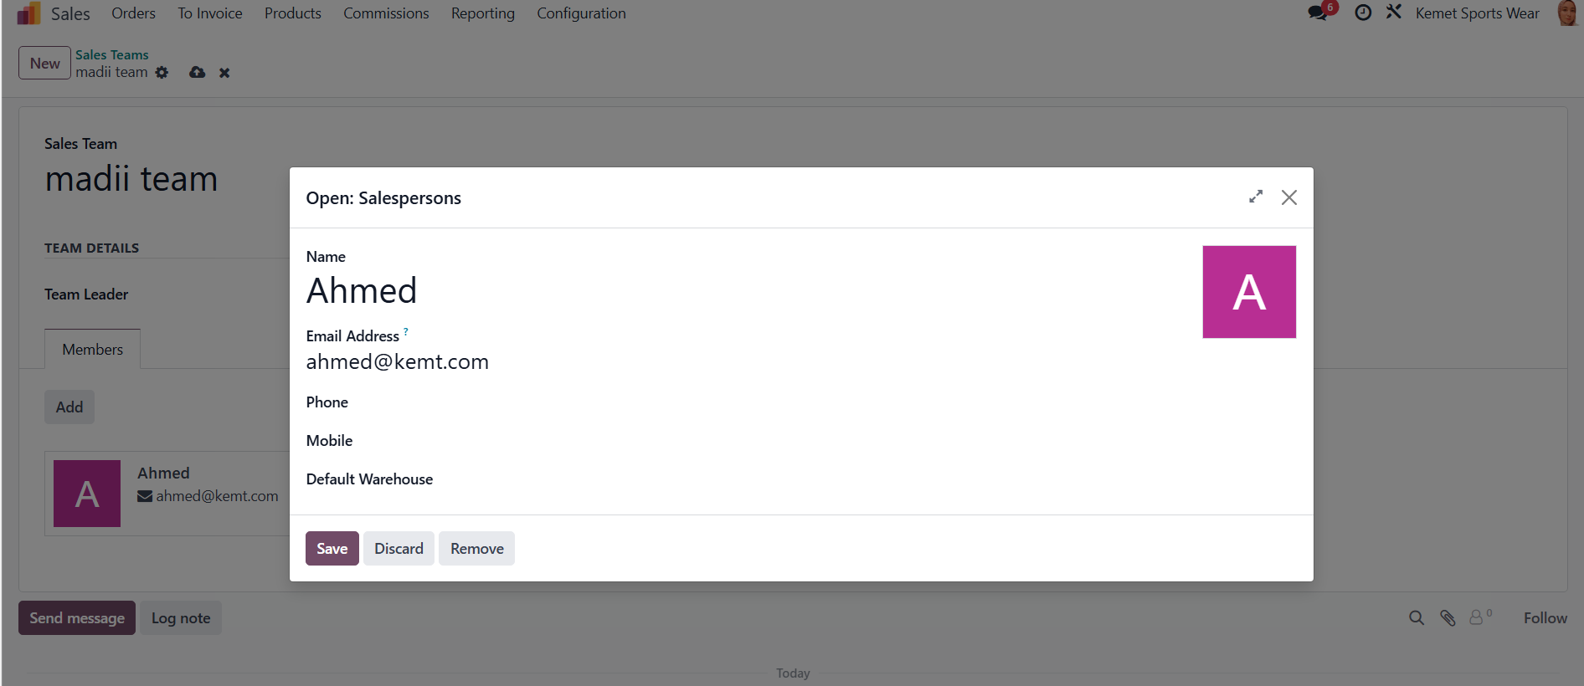

23- add team leader

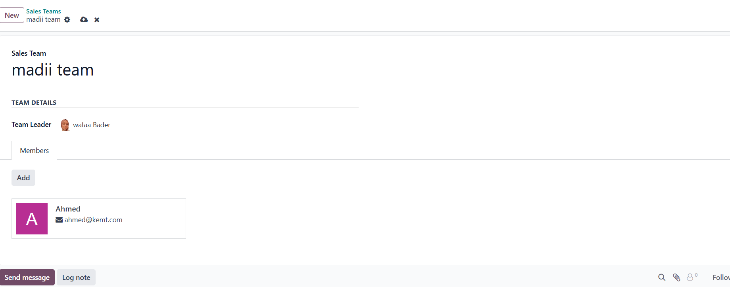

24- create new pricelist

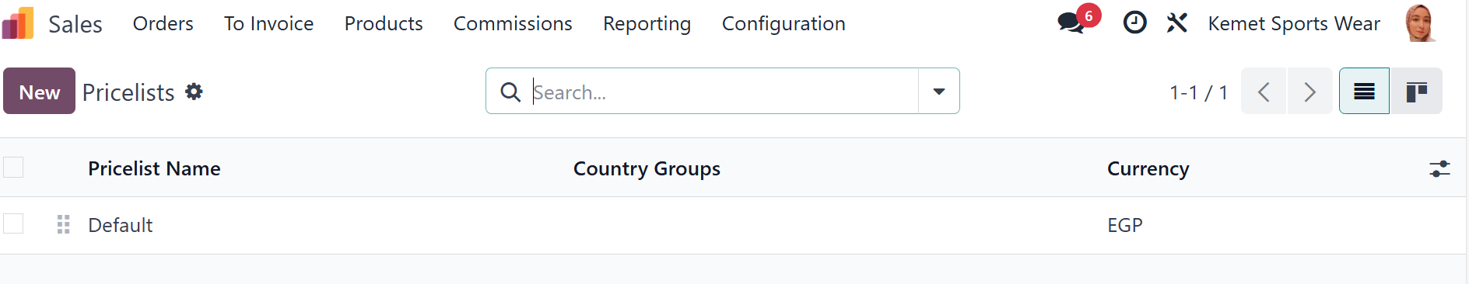

25- create pricelist rules

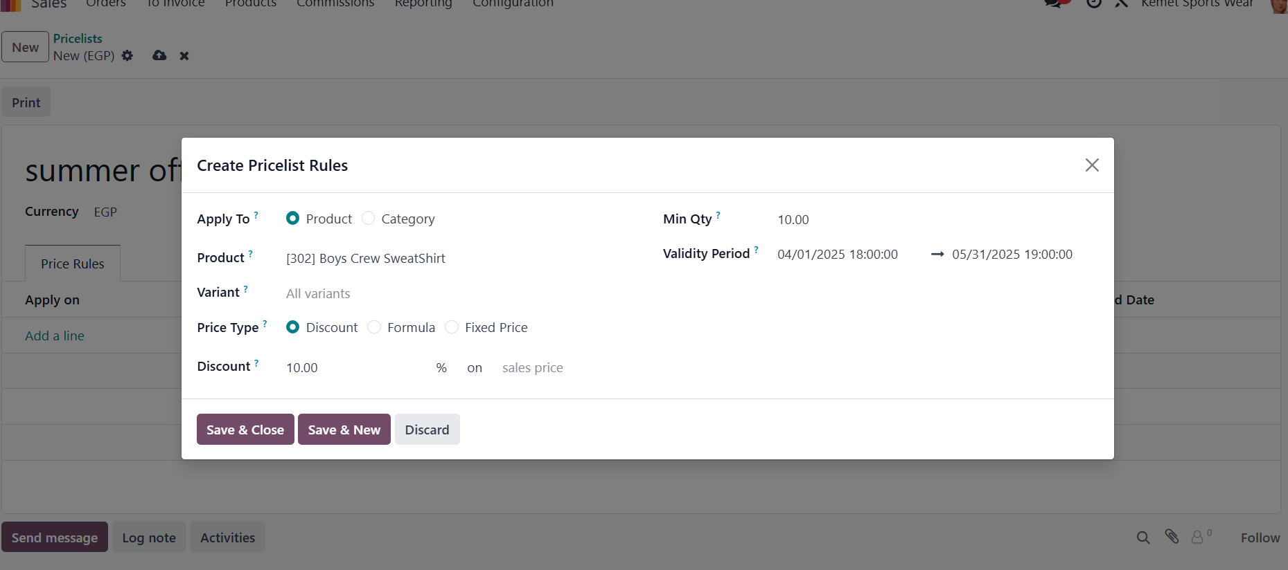

26- link customer with pricelist

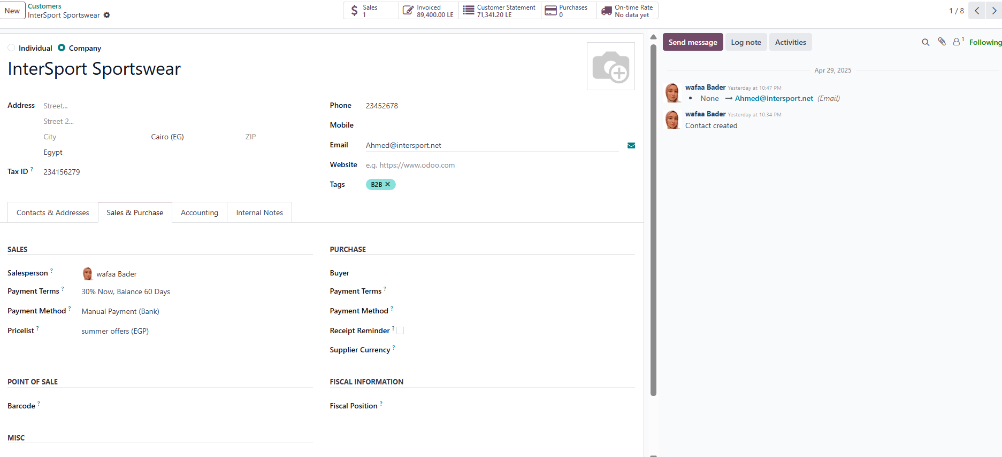

27- create quotations templets

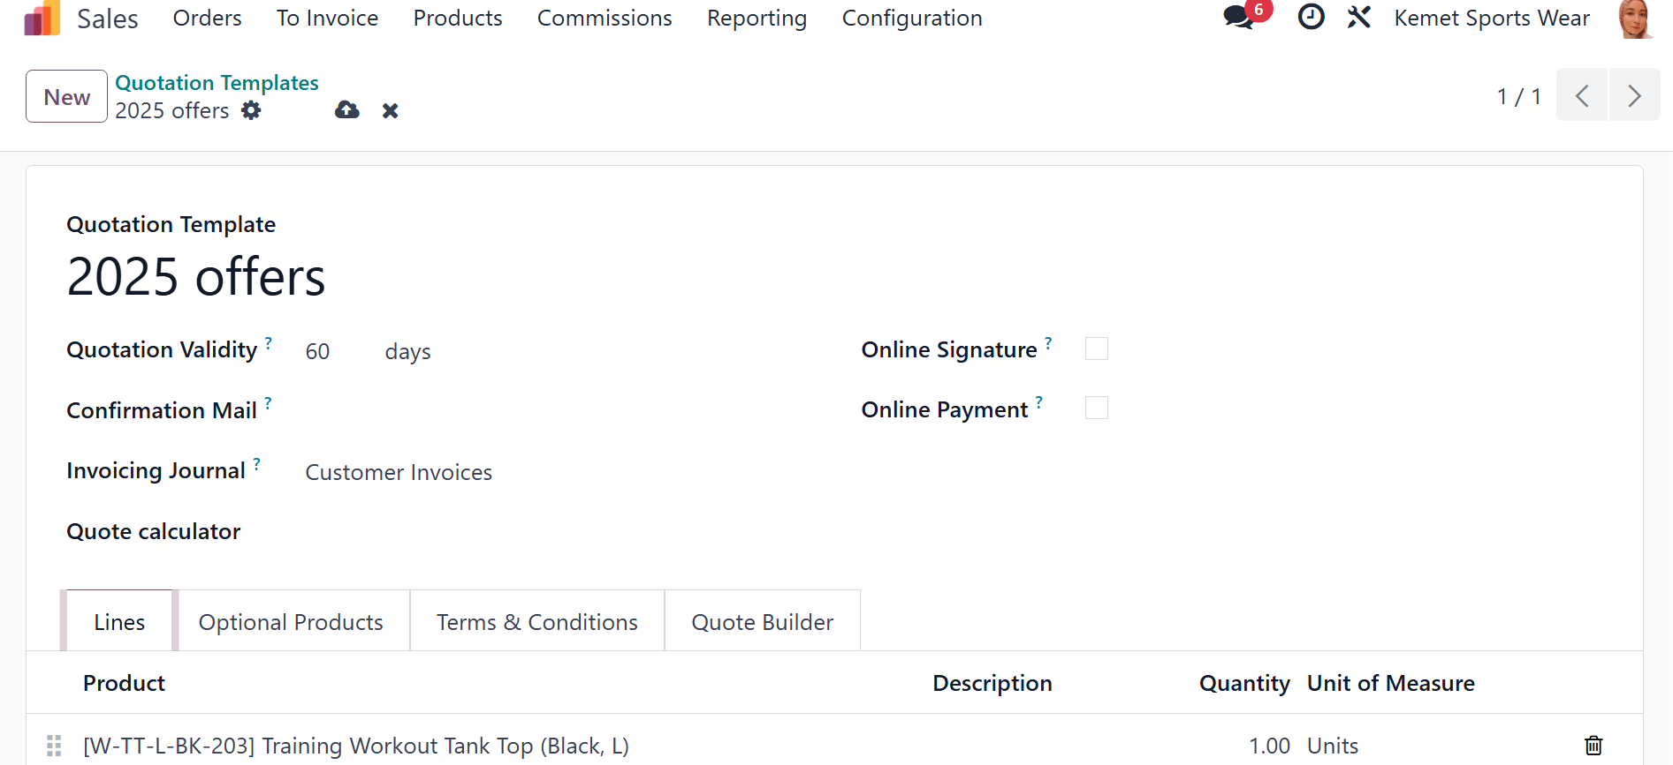

28- link quotation templates with quotation

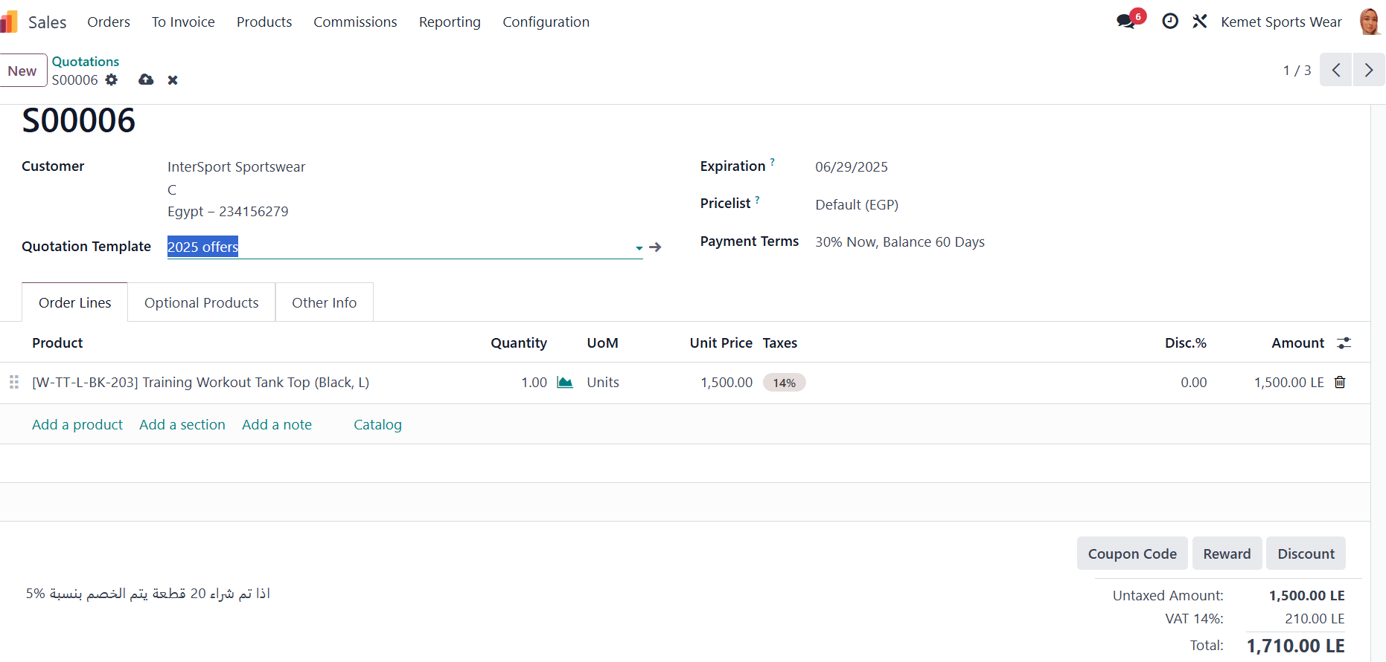

**Pro Sync integrated Solutions** **Kemet Sportswear Co.**

**Odoo ERR Consultant**  **Project Manager**

Ms. Wafaa Reda MR. Atef Ibrahim